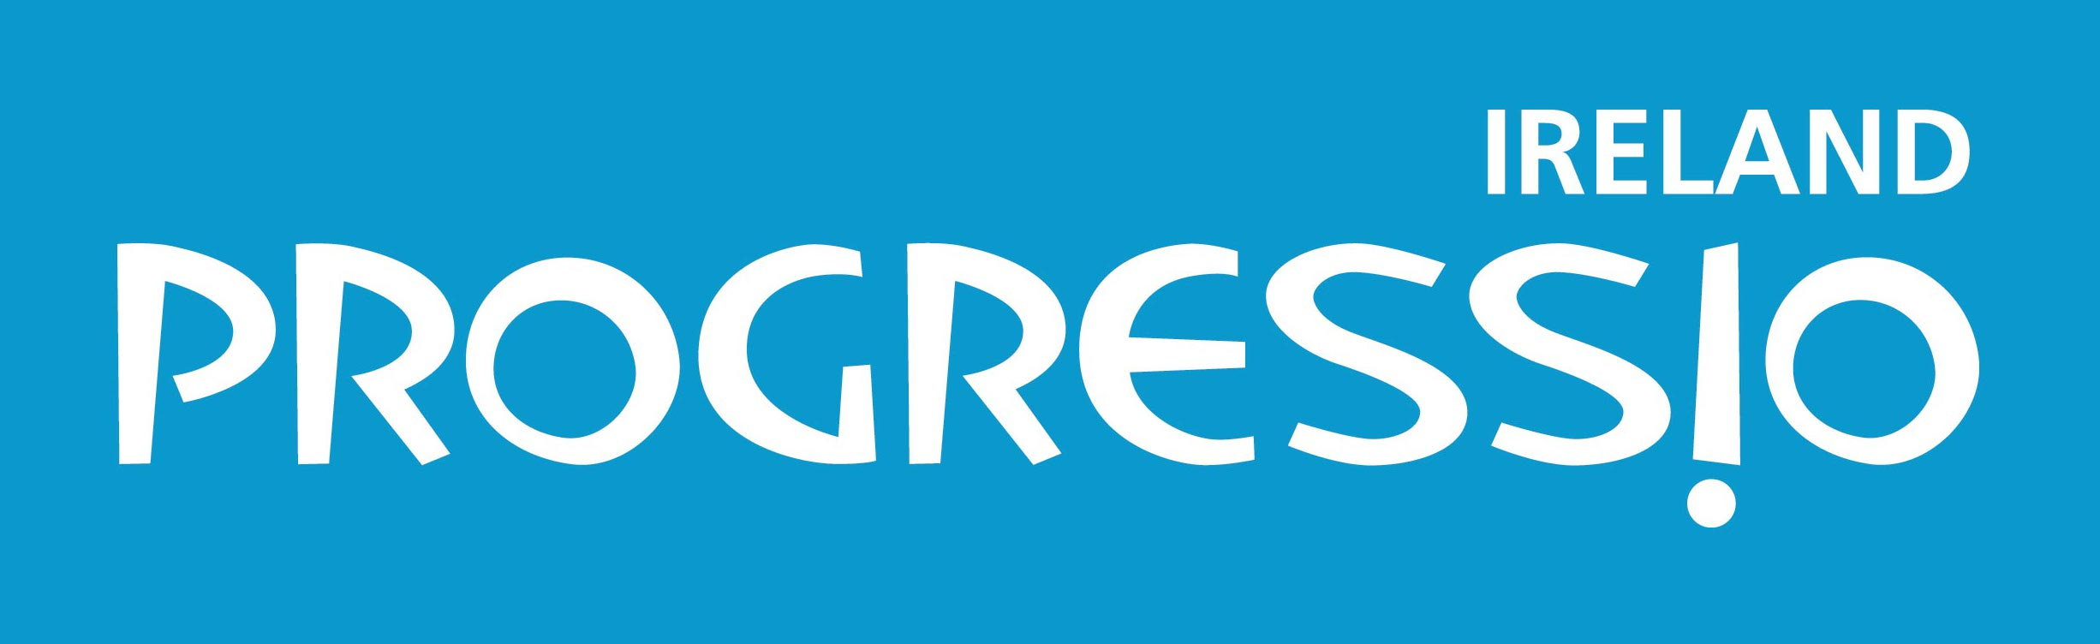

Submission on the Outline Heads of the Climate Action and Low-Carbon Development Bill

Introduction

Progressio Ireland is an independent Irish international development organisation. As part of the wider Progressio family, we are engaged in 11 countries around the world. Through our skill-sharing and long-term development worker programme, we work in partnership with social movements, church groups, networks, NGOs and civil society and other local organisations to facilitate people’s active participation in their own development. Contributing to structural change at a global level is fundamental to Progressio Ireland’s work.

One of the key areas of our work is sustainable environment. We believe that unsustainable patterns of global production and consumption, especially in the North, are creating a perfect storm of climate change, environmental degradation and resource scarcity for many poor and marginalised communities. Frequently it is these poor and marginalised communities that are living at the sharp end of climate change; and it is these communities that ultimately lack the resources to adapt to their changing circumstances. We are already seeing the impact of climate change in the countries and communities in which we work.

In our sustainable environment programme we are directly involved in responding to the climate change challenge. We are working with individuals, groups and communities to develop climate change resilient farming techniques and to increase the benefits from their output through training and facilitating access to market for their products; we are working with individuals, groups and communities to improve the ways in which they access and use water, forest or coastal resources through steps like combating desertification and improving water harvesting; we are working to support communities to demand improvements in transparency, accountability and responsiveness of local and national authorities in areas such as sustainable, equitable watershed management and we are working with partners across Europe (particularly in Ireland the UK) to try to secure clear accountability and responsiveness from the European Union, members states and multi-lateral institutions in advocacy areas such as illegal logging, water legislation and climate change.

Executive Summary

Progressio Ireland works in partnership in many poor and marginalised communities in 11 countries around the world. In these countries we are already seeing the impact of climate change on lives and livelihoods.

The Climate Action and Low-Carbon development Bill should allow Ireland to map out a future for the Irish people that is strong and sustainable. However, that needs to be in the context of Ireland living up to its global responsibilities. Ireland has benefitted from a relatively high level of carbon use over the past decades. Its development has been dependent on that. Ireland therefore needs to actively contribute both to the amelioration of the situation as well as to softening the impacts for poor and marginalised communities around the world.

A key principle of sustainable development is that of “common but differentiated responsibility”. This needs to be one of the key guiding principles in the formulation of the bill and the whole idea of climate justice needs to be at its heart.

Ireland is rightly proud of its track record in international development. A strong climate bill will ensure that climate policy is coherent with the desire of the Irish government to make a positive impact on the world through contributing effectively to the global fight against poverty.

Our key recommendations are outlined below. Our over-riding concern is that the bill is strong enough to ensure that Ireland can live up to its responsibilities; that it is clear enough that the various actors can make the right decisions and that there is a clear and transparent way of ensuring that Ireland as a nation is keeping on track.

Our Recommendations

Climate Justice
- At the core of the bill needs to be the issue of climate justice. Climate change is a global problem for which the higher polluters have a stronger responsibility. We ask that the principle of climate justice be included in the bill.

Targets
- The bill needs to be strong if it is to be effective, and to offer Irish society the right incentives for action. We ask that a strong target of a cut of emissions of between 80 – 95% be set for 2050.

Keeping on track
- There needs to be a way of ensuring that Ireland remains on track. We ask that low carbon roadmaps, with carbon budgets, are done every five years.

Our submission

1. What we see
Climate change is happening now. We are seeing the impacts on the ground. Weather patterns are changing fast, and affecting the ability of communities to sustain dignified livelihoods.

The scientific community warns that global warming must not go beyond 2 degrees centigrade. Indeed, even at 2 degrees the changes to climate will be severe and the impacts often devastating. Currently the global temperature increase is moving beyond 1 degree and rising fast. Urgent action is required if we are not going to accelerate quickly beyond the 2 degree mark, and the resultant devastation that that would bring.

This is not a cold, dry theoretical debate. This is about real people feeling the effects now; their minimal resources being pushed to the limit as they try to continue to deal with the consequences of a climate change for which they have not been responsible. In part the change is about increasing droughts and floods, often in the same areas, such as Salima district in Malawi. But one of the most frequently reported and most devastating impacts is the unpredictability of the weather. In Central America, for instance, the sowing of which crops, where and at what time of year was had been developed over many decades of similar weather patterns. Over the last 2 decades, these patterns have become un-recognisable, with too much rain sometimes, and too little at other points, making it difficult for farmers to plan and maintain crops.

2. What needs to be done
Adaptation by communities who are suffering the impacts of climate change is key. As an organisation, this is an important element of our sustainable environment work. For example we are working in communities on the shores of lake Malawi who are facing high levels of food insecurity due to flooding, dry spells and poor soils; all of which have been exacerbated by climate change. With our partner Environment Africa we are training small-scale farmers to farm sustainably and better manage scarce resources, increasing both their productivity and their resilience.

However, adaptation is never going to be enough. We cannot continue doing things the way we have been doing, and hoping that we as a global world can adapt. Although more resources for adaptation are needed, this will not be enough unless, as a global community, we can make serious changes to our development models in order to find a path towards the sustainable management of our planet.

Climate change is a justice issue. Based on the principle of common but differentiated responsibility, it is essential that those who have been the largest polluters take the biggest responsibility for changing the dangerous trajectory we are on.

Ireland is a country that has benefitted from a relatively high level of carbon use over the last decades. The proposed Climate Action and Low-Carbon Development Bill needs to be a strong bill that will offer the appropriate incentives to business and other actors to invest in and contribute to a sustainable future for Ireland, also ensuring that Ireland is taking its global responsibilities seriously. It needs to build a framework for cross-governmental coherence. Ultimately it needs to provide the basis for a flourishing economy that, at the same time, allows for a substantial cut in emissions.

3. The recommendations

Climate justice
Climate justice should be a key principle included in the bill. This will help ensure that the Bill will reflect the obligation of the Irish government to focus on both mitigation and adaptation. While ensuring that the principle is included in the Bill will not automatically lead to policy coherence, it will act as a reminder of the need to look at policy coherence across all departments.

Targets
In order that the correct investments are put in place now, towards a low-carbon, sustainable future, it is essential that there is certainty with respect to government policy. Uncertainty and a general vagueness about the actual transitioning to a low carbon economy within the Bill will lead away from the correct levels of investment and will create a climate of procrastination.

While there is a target in the Bill for 2020, this targets needs to be looked at, and should include the whole economy. What is most definitely essential is that there is a target for 2050 of a reduction of emissions of 80 – 95%.

In order to ensure that Ireland reaches this target, it will also be important to have interim against which progress can be measured. These interim targets should be set for 2030 and 2040.

Keeping on track
Targets are essential, but so are additional mechanisms that ensure that the process is on track. There are mechanisms in the bill. The recommendation here is just to make them that bit stronger.

Firstly, carbon road maps should contain carbon budgets. This is important because the budgets go beyond a the snap-shot that is the target, to reveal the actual total emissions over a particular period. Secondly, the road maps should run for a shorter period than currently contained in the proposed bill. Both these measures would ensure that all governments would have a responsibility for delivering towards the 2050 target. It would successfully abolish a culture of procrastination that could exist if such measures were not taken.

Dr. Judith Turbyne
Director, Progressio Ireland
director@progressio.ie
083 421 2508, 01 6144966

